MANAGING CUSTOMER RELATIONSHIP: A CASE STUDY OF COMPLETE SPORT NEWSPAPER.

NAME: OLADIMEJI E ALADEROKUN

Dissertation submitted in partial fulfilment of the requirements for the MSc INTERNATIONAL MANAGEMENT

Content Page

Table of figures

List of tables

Abstract

Acknowledgement

Chapter 1 Introduction…………………………………………………………………………..…….1

Background Information…………………………………………………………………..….1

The Nigerian Newspaper Industry……………………………………………..…….…….6

Complete sports newspaper…………………………………………………..….…….7

Problem statement…………………………………………………………………….….....7

Research Aim and objectives……………………………………………………………….…….8

Research Questions…………………………………………………………………….……..8

Significance of the Study………………………………………………………………………..8

Scope and (De) limitation of the study……………………………………………….………9

Research Methodology………………………………………………………………………..9

Chapter 2 Literature review…………………………………………………………………10

Conceptual framework…………………………………………………………………………10

Customer relationship management………………………………………………………….10

E-CRM……………………………………………………………………………………..14

Importance of Customer Relationship Management…….…………22

Aspects of customer relationship management………….…………………….……24

Customer satisfaction and retention…………………………………………………..27

Relationship management………………………………………………………………….28

Managing Knowledge…………………………………………………………………….29

Customer lifecycle management………………………………………………………….30

Effect of Customer Relationship……………………………………………………………31

Effect of Satisfaction on Customer Loyalty…………………………………………………32

Indirect effect of Customer Relationship Management on Customer Loyalty through Customer Satisfaction………………………………………………………………………………….32

Value creation process………………………………………………………………………….33

Chapter 3 Research Methodology………………………………………………………..35

3.1 Introduction……………………………………………………………….35

Research Design……………………………………………………………………………35

Philosophical Stance………………………………………………………………….36

Data Collection…………………………………………………………………………..36

Data Analysis……………………………………………………………………………..36

Customer research……………………………………………………………………….39

Chapter 4 Results and discussion………………………………………………………….41

Chapter 5 Conclusion and recommendation…………………………………………………51

REFERENCES

APPENDIX

LIST OF TABLES

TABLE 1: Customers’ opinion on complete sport newspaper…………………….48

LIST OF FIGURES

Figure 2.1: Conceptual framework…………………………………………..10

Figure 2.2: Customer lifecycle……………………………………………….31

GRAPH 1: Age distribution…………………………………………………..41

GRAPH 2: Gender distribution………………………………………………...42

GRAPH 3: Relationship length…………………………………………………43

GRAPH 4: Reasons for choosing Complete sport newspaper………………….44

GRAPH 5: Reasons why customer switch to complete sport newspaper………46

DECLARATION

Any other work aside this was stolen.

Name: ALADEROKUN E OLADIMEJI

Date: 15/09/2022

ACKNOWLEDGEMENT

Words cannot express my gratitude to God Almighty who has been the source of my strength and provider throughout my studies.

I would like to thank my mother Mrs. Tabitha Ibrahim for being there for me both spiritually, financially, and emotionally. Thank you for your encouragement and keen interest in my academic achievement. I love you so much.

I wish to extend my appreciation and thanks to my supervisor Dr Mildred Brown- Houston for her guidance and advice carried me through all the stages of this project I am grateful.

To my classmates too Whose names may not all be enumerated, their contribution when it comes to studying together and working as group with assessment cannot go unnoticed.

ABSTRACT

Businesses has to and are in a constant race to increase profits, keep current customers and gain new ones, on a globalized market like never before, especially in today’s world where the internet has affected even the distribution of goods and services and evident in the newspaper industry. Until the 1990s to 2000s, most publications were government-owned but now we have from private individuals.

The subject of the thesis was managing customer relationships. The theoretical part concentrated in overall customer relationship management, digital customer relationship management (E-CRM), customer satisfaction, retention and commitment. The empirical part was executed via quantitative customer research. A survey was made to measure the level of customer commitment. In addition, the survey measured customer loyalty and satisfaction. It was also studied which reasons are important for customers to prefer a newspaper company and why they have switched from one newspaper company to another.

The survey questionnaire was designed according to the theory part to find out reasons for customers to switch their newspaper company and subscribing to a particular newspaper. It was found out that the price is not the only factor when comparing newspaper companies. When customers had changed their newspaper companies, the most common reasons were price (18 %), customer service (17 %), content (14 %), Reputation (15 %) and online presence (12 %). The four most important factors for customers to choose complete sport newspaper were customer service (19.5 %), content (18.7 %), price (14 %) and online presence (15.6 %).

Partnering with complete sport, researchers can examine the effect of customer relationship management on revenue of a newspaper. This should be done by expanding the respondent size and perhaps cover more geological locations. But this could also lead to interviewing staffs of the company and maybe perhaps getting official company’s financial data. This is recommended for further research.

**CHAPTER ONE**

INTRODUCTION

**1.1 Background Information**

Customer relationship management (CRM) has been regarded as a set of processes and systems which support the business structure in sustaining profitability and maintaining relationship with key customers (Canadian Institute for Knowledge Development Publishing, 2012). Customer relationship management (CRM) is the combination of practices, strategies and technologies that companies use to manage and analyze customer interactions and data throughout the customer lifecycle, with the goal of improving customer service relationships and assisting in customer retention and driving sales growth. CRM systems compile customer data across different channels, or points of contact between the customer and the company, which could include the company's website, telephone, live chat, direct mail, marketing materials and social media. CRM systems can also give customer-facing staff detailed information on customers' personal information, purchase history, buying preferences and concerns.

When we think about the deepest meaning of CRM, one could say it is more like a way of thinking than just one practice and needs to truly be taken as part of the company culture. The “C” in CRM can have a narrow definition or a wide one. For instance, customers can include not only those who buy from you, but also your suppliers, your partners, your employees and your investors. Each of these “customer groups” will have different needs that have to be managed. For the purpose of this thesis, we will focus on the “customer” as someone who buys your products or services.

There are a number of working definitions for CRM. In fact the letters CRM have been used to identify Continuous Relationship Marketing, Customer Relationship Marketing and Customer Relationship Management. Each term represents the same process. CRM can be defined as a process that maximizes customer value through on-going marketing activity founded on intimate customer knowledge established through collection, management and leverage of customer information and contact history. CRM is about perfecting relationships to maximize a customer’s value over time. CRM is part of an evolution in corporate thinking that began with the Enterprise Resource Planning (ERP) initiative of the 1990s. ERP forces all resources within a corporation to work within one business system. In the 1990s, over $300 billion was spent on centralizing, standardizing and organizing information and resources throughout U.S. corporations. The results, however, have been mixed in terms of payout. What is indisputable is that the information system processing skills acquired in implementing ERP programs enabled many organizations to support CRM and E-commerce programming; initiatives not in existence when ERP began. CRM was developed, in large part, as a result of data mining, or segmentation and targeting research, made possible from the centralization of customer records. Organizations began to realize that they could better serve customers since they better understood customers. CRM has benefited from advances in data management and middleware new software that allows disparate data resources to work as a single integrated database. CRM has also been supported by a new generation of promotional tools; for example, selective binding, variable valuation and new probabilistic targeting tools such as Spectra. In the U.S., CRM is now practiced by approximately 45% of the companies in retailing, aircraft and utilities; 50–55% of the companies in financial services, pharmaceuticals and transportation; and 70% of the companies in telecommunications and credit.

Customer relationship management (CRM) is one of the paramount business approaches that enable firms to understand ever changing preferences of customers to induce their behaviour. It involves result-oriented dialogue between an organization and its customers. This is done to improve and increase the customer acquisitions, customer retention, their profitability and positive relationship between firms and clients (Al-hawari, 2015; Hassan, 2018; Heinonen, 2014; Jan & Abdullah, 2014; Maggon & Chaudhry, 2018; Padmavathy, Balaji, & Sivakumar, 2012; Thakur, 2014). Both relationship marketing and CRM are much similar to each other and are used in the maintenance of customer relations (Parvatiyar & Sheth, 2001). However, the trust that is built by the quality of relationship between the seller and the buyer has been the main source of relationship marketing (Huang, 2015). Thus, the relationships so developed benefits both firms and customers (Filip, 2013; Ku, 2010; Lin, Chen, & Chiu, 2010; Maggon & Chaudhry, 2015; Mechinda & Patterson, 2011). Owing to the successful effects of adopting CRM, majority of business organization have focused their attention to utilize CRM (Akroush, Dahiyat, Garaibeh, & Abu-Lail, 2011; Mohammad, Rashid, & Tahir, 2013; Rahimi, 2017; Santouridis & Veraki, 2017). Also, the extent to which organizations are committed in building and maintaining relationship with client determines market competitiveness. This guides the top management about customer’s behavioural intentions (Mehta, Sharma, & Mehta, 2010). Therefore, for effective and solid customer relations, firms need to implement CRM widely in its settings (Chang, Park, & Chaiy, 2010). The key aspect of CRM is customer differentiation; CRM framework needs to recognize the differing needs of customers. However, customer differentiation may lead to dissatisfaction among customers, if the organization does not address this issue while implementing CRM framework (Nguyen & Mutum, 2012). Moreover, with the advances in IT infrastructure, the business organizations are serving customers differently as well as effectively and efficiently (Ramesh, 2013; Tian & Wang, 2017; Zablah, Bellenger, & Johnston, 2004).

Lately the upcoming of the internet has affected the distribution of goods and services. This has consequences for the newspaper industry, creating a revolution in journalism (Guo & Sun, 2004). New information systems accelerate the process of news reaching the reader, the distribution costs and the chance to connect with readers in a more direct way, where readers might even play a role in the journalistic offer (Flavián & Gurrea, 2009). Especially with this covid-19, businesses are moving from a mix of analog and digital to completely digital. Consumers’ choices also point towards this (Mckinsey.com, 2020). Consumers want this information in ease and comfort. Digitization affords that. The internet has removed all geographical boundaries, and as a worldwide platform, it has extensive global audience reach. Today, information dissemination is instant and more efficient in reaching the target audience. This is facilitated by the zero marginal cost associated with digital news content and exchange of messages via the internet, unlike print and broadcast media that have to account for additional printing and delivery costs when expanding their reach. The mere ability to access information and receive instant updates on the internet threatens the purpose of newspapers, and it has evidently been a growing source of competition and contention for the newspaper publishers (Sajjad, 2013).

One important aspect of the CRM approach is the systems of CRM that compile data from a range of different communication channels, including a company's website, telephone, email, live chat, marketing materials and more recently, social media. Through the CRM approach and the systems used to facilitate it, businesses learn more about their target audiences and how to best cater to their needs.

The development and popularity of electronic marketing as a tool has produced a rich source of consumermdata for access by organizations in many industries. Focusing on the retail grocery industry in the U.S., Frequent Shopper Programs (FSP’s), are used by grocery retailers who comprise over 60% of the All Commodity Volume. They have produced consumer files that will be the key to more profitable grocery promotion for them in the future. Companies like Safeway, Kroger and American stores are heavily invested in these programs. Frequent shopper programs in the grocery industry developed as loyalty program extensions. These programs are consumer card-based programs that track purchases based on the use of scanners and reward customers with discounts based on brands purchased. These programs were developed to provide customers with an additional reason to increase their share of purchase in a particular chain of stores.

The concept of customer lifetime value, the money value of a customer relationship over time, has evolved to enable savvy direct marketers the opportunity to differentiate the profit potential for each of the various market segments that they serve. Loyalty marketing has always focused on the fact that retaining and improving business with current consumers costs less than acquiring new customers. Customer retention, as a strategy, is founded on the ability to segment and differentially target current users to improve the value of the relationship for both seller and buyer.

**1.1.1 The Nigerian Newspaper Industry**

The history of news media in Nigeria goes as far back as the 1840s when European missionaries established community newspapers to propagate Christianity. This initiative later gave rise to the establishment of some newspaper outfits in Nigeria by the likes of Dr. Nnamdi Azikiwe in 1937, titled West African Pilot. The powerful influence manifested by the paper led to the establishment of many newspapers, especially in the 1960s. These newspapers deliberately wrote seditious and criminally libelous articles against colonial governments leading to an eventual independence. Following independence and the crises of adjustment that accompanied it, the local leaders who took over from the British were however, wary of the press, and so not as tolerant. Those that witnessed the struggles of the newspaper industry and survived to tell the story actually thinned out.

Until the 1990s to 2000s, most publications were government-owned, but private papers such as the Daily Trust, Nigerian Tribune, The Punch, Vanguard and the Guardian continued to expose public and private scandals despite government attempts at suppression. The newspapers industry growth in Nigeria has seen a steady decline on circulation and therefore sales revenue. According to Dare (2011), the reasons for this decline might include high cost of newsprint and in recent times, the advent of the internet and the variety of online platforms that allow readers to obtain news & information for free and interactivity. Recent statistics showed that Nigeria has the highest internet users in Africa (Internet World Stats, 2017). Obijiofor and Green (2001) has maintained that there are still chances for newspapers to struggle and survive. They can position themselves to positively face the challenges of 21st century. Hassan et al., (2015) suggested that newspaper publishers should strategize ways to fully embrace their technological fate and enhance quality print run. Aliagan (2015) also found that it is necessary for Nigerian newspapers to create certain strategies to avoid mortality.

**1.1.2 Complete sports newspaper**

Complete Sports (CS) is Nigeria’s number one all-sports daily newspaper. It was first published in December, 1995. It is the most-widely-read sports publication in Nigeria. (All Media and Product Survey (AMPS) research, 2008 and 2009). Complete Sports (CS) is published by Complete Communications Limited (CCL). CCL is the oldest and longest-running sports publishing group in Nigeria. It was established in 1984 but incorporated as CCL in 1987. The primary focus of CS is sports news about Nigeria and the exploits of Nigerian sportsmen and women both at home and abroad, particularly the footballers. On the website home page, there are sport bet services and links to favorite betting sites. The company also offer a variety of sport gears, weight reducing supplements and body fitness gadgets for their customers to buy online and get delivered.

**1.2 Problem statement**

At the present time when the majority of companies are still dealing with impacts of the economic crisis, new solutions on how to restructure companies and keep customers are being searched. There are a lot of options how to solve it. This research deals in detail the utilization of technology and business strategy using customer relationship management (CRM) and more precisely on customer retention. Several newspaper companies have been knocked out of the industry due to lack of proper understanding and management of customers’ relationship. Furthermore, few companies that understand these changing trends do not know how to objectively switch as they should, thereby affecting their net sales and organizational objectives achievement.

**1.3 Research Aim and objectives**

The aim of this thesis is to investigate the effect of customer relationship management on Complete sport newspaper. The objectives include:

1. To find out the overall opinion of customers on Complete sport newspaper

2. To examine the amount of satisfaction among Complete sport newspaper readers

**1.4 Research Questions**

There were some questions guiding the thesis, such as:

1. What is the overall opinion of customers on Complete sport newspaper
2. How could the relationship be improved, and what makes customers stay with one company and become loyal to it
3. What is the amount of satisfaction among Complete sport newspaper readers
4. What is the impact of digitilization on Complete sport newspaper

**1.5 Significance of the Study**

A newspaper business is a competitive one and it is interesting to start to find reasons customers prefer one and could switch subscriptions. The significant impact of this study is to serve as a verifiable platform for newspaper industry. The adoption of technical and adequate innovations of this research could possibly result in phenomenal and exponential growth in the market dominance. Similarly, the result of analysis of customers relationship trend will impact the newspaper companies to make informed decisions, and hence enhance their decision-making power to further advance their course and actions and achieve greater organizational goals and objectives.

**1.6 Scope and (De) limitation of the study**

This study centers on the Complete Sport and this is in Nigeria so it limited to a region. However, the research will make judicious use of relevant analysis by examining different data of customers’’ behavior from journals, literature and past findings with respect to customers and manufacturers.

**1.7 Research Methodology**

The research was made in order to find out the overall opinion about the complete sport newspaper company and the amount of satisfaction among the customers. The questionnaire consisted of 10 questions. Both open- and closed ended questions were used. A total of sixty- eight (68) people were interviewed around Ikeja - Ikorodu in Lagos. The survey was completed using Qualtrics. Before starting, the intention and reason for the survey was explained to the participants. The interviewee was given a possibility to open up their answers or give other feedback. The interviewees were also thanked for their replies.

**CHAPTER TWO**

1. **Literature review**

This chapter of the research will explain the concept of customer relationship management, pointing towards customer retention and its significance to newspaper business and industry.

* 1. **Conceptual framework**

DEPENDENT VARIABLE

CUSTOMER SATISFACTION AND RETENTION

INDEPENDENT VARIABLE

CUSTOMER RELATIONSHIP MANAGEMENT

MEDIATING VARIABLE

DIGITIZATION; E-CRM

Figure 2.1: Conceptual framework

* 1. **Customer relationship management**

The expression, Customer Relationship Management (CRM), has been in use since the early 1990s. Since then, there have been many attempts to define the domain of CRM. It has been an area of interest for most marketers and organizations. Heskett (1987) brought out the concept of market economics, in which he stated that results can be achieved in a better way by understanding the customers rather than concentrating on developing scale economies. In today’s dynamic and very competitive world of numerous news providers, rising costs, and demanding customers most especially in the current economic crises, it has become imperative for organizations to focus on maintaining customer loyalty and retaining customers. CRM relates to strategy, managing the dual-creation or value, the intelligence use of data and technology, the acquisition of customer knowledge and the diffusion of this knowledge to the appropriate stakeholders, the development of appropriate (long-term) relationships with specific customers and /or customer groups, and the integration of process across the many areas of the firm and across the network of firms that collaborate to generate customer. Handen (2000) defines CRM as the process of acquiring and retaining valued customers. He further states that in order to be successful in the future, organizations need to better understand customers’ needs. CRM aims at establishing new relationships and developing them to best serve the interest of the company and shareholders through profitability, and the interest of the customer through value added. CRM creates long-lasting relationships by combining modern technology with modern way of thinking. Thus, CRM enables companies to really focus on one or several groups of customers, which isn’t possible in traditional marketing. The current trend is that customers no longer stay in one company but easily switch to another. They have triggered a new era of creating competitive advantage through customer orientation.

Elements of CRM

CRM can be broken down into a number of different components which many software vendors have developed packages for. For the most part, there are three areas which are core to successful customer relationship management:

Customer Service: The customer service function in your company represents the front office functions that interact with your customers. These are the business processes that allow your company to sell products and services to your customers, communicate with your customers with regards marketing and dealing with the after-sales service requirements of your customers. Each interaction with the customer is recorded and stored within the CRM software where it can be retrieved by other employees if needed. Sales Force Automation Your company’s sales department is constantly looking for sales opportunities with existing and new customers. The sales force automation functionality of CRM software allows the sales teams to record each contact with customers, the details of the contact and if follow up is required. This can provide a sales force with greater efficiencies as there is little chance for duplication of effort. The ability for employees outside of the sales team to have access to this data ensures that they have the most recent contact information with customers. This is important when customers contact employees outside of the sales team so that customers are given the best level of customer service.

Campaign Management: The sales team approach prospective customers in the hope of winning new business. The approach taken by the sales team is often focused in a campaign, where a group of specific customers are targeted based on a set of criteria. These customers will receive targeted marketing materials and often special pricing or terms are offered as an inducement. CRM software is used to record the campaign details, customer responses and analysis performed as part of the campaign.

Apte et al. (2002) have argued that these activities remain distinct from web-enabled CRM (E CRM). Web-enabled CRM (E-CRM) is recognized by most firms as an additional channel for communication or sales and the firms are recognizing that open standard Internet TCP/IP protocols, XML and Internet telephony are not only cost effective but also enable better contacts with customers. According to Lee-Kelley et al. (2003), E-CRM refers to the marketing activities, tools and techniques delivered via the internet which include email, world wide web, chat rooms, e-forums, etc., with a specific aim to locate, build and improve long term customer relationships to enhance their individual potential.

There are numerous academic evidences of CRM effectiveness and its importance in industry sectors (Brun, Rajaobelina, & Ricard, 2014; Coltman, Devinney, & Midgley, 2011; Elkordy, 2014; Maggon & Chaudhry, 2018; Rahimi, 2017; Rahimi & Gunlu, 2016; Santouridis & Veraki, 2017; Sayani, 2015; Wang & Feng, 2012). There is scarcity of research in the context of service sector to validate the effect of successful implementation of CRM, especially in Jammu and Kashmir region. Also, previous studies have limited their scope in adopting dimension proposed by Sin, Tse, and Yim (2005). On the other hand, other dimension of CRM have largely remained unexplored; thus, this study is pioneering in integrating other dimensions with the existing CRM framework. Moreover, the additional dimensions incorporated in this study are specially tailored to newspaper company. The article analyses the results of the study. This was done so that the company is benefited to serve the customers more profitably and yet fulfil his aspirations and delight him with better solutions. This shall also benefit the firms in customer retention through positive collaborative relationships. Further, the acquisition costs can reduce to a great extent as well as increase in customer empowerments.

* + 1. **E-CRM**

Jones and Sasser (1995) have told that customer relationship is influenced by the nature of the product or service, type of industry and competitive environment. Customer loyalty building in Internet-based relationships is particularly difficult in the highly competitive and new ambience as it depends largely on impersonal context of Internet-based transactions. According to Sheth, Sisodia and Sharma (2000) the Internet helps firms to understand the customer needs better, develop more customer centric programs and to satisfy their needs, offer enhanced value through managing customer information and also providing customized products and services. E-CRM is not at all applied to change the whole marketing activities but to enhance the marketing activities by presenting opportunities to companies to improve their effectiveness and also to deliver valued products to customers (Scullin et al., 2004). It may reduce the costs involved in communicating to customers, optimize work flows as a result of integration with other enterprise systems, facilitate better market segmentation and would be able to enhance customer interactions and relationship (Adebanjo, 2003). The role of E-CRM in business systems is to improve customer service, retain valuable customers and to aid in providing analytical capabilities within an organization (Fjermestad and Romano, 2003). It allows organizations not only to retain customers, but enables more effective marketing, creates intelligent opportunities for cross selling and opens up the possibility or rapid introduction of new brands and products. To be able to deliver these benefits, organizations must be able to customize their product offering, optimize price, integrate products and services and deliver the service as promised and demanded by the customers. (Jukic et al., 2002). Using technology to optimize interactions with customers’ companies can create a 360-degree view of customers to learn from past interactions to optimize future ones (Chen and Popovich, 2003).

At the present times, E-CRM is emerging as the core marketing activity for businesses that can effectively counter the competitors in a fiercely competitive ambience. Effective E-CRM is all about the overall process of building and maintaining customer relationships by delivering superior customer value and satisfaction. E-CRM extends to all the stakeholders that create value for the customer. Value for the customer may be delivering the products at lower prices, higher quality products and services, continuous stream of innovative new products and customization of products and services. By using technology, E-CRM helps the marketers to differentiate themselves from the competitors and can also offer the products or services either cheaply or at better rates than its competitors. The new customer is fickle, demanding, informed, and in the driver’s seat ensuring more responsibility on the part of a seller.

For example, financial organizations are now taking advantage of mobile marketing services and in particular mobile banking based on Wireless Application Protocol (WAP) technology, escrow, blockchain, NFTs and cryptocurrency as powerful new marketing tool. More so, companies even in particular Complete sport newspaper is partnering with these financial organizations to serve customers better and faster and in turn build long lasting and mutually rewarding relationships with new and existing customers. The internet is advancing E-CRM and it has features that are attractive to customers and business organizations. The differences between CRM and E-CRM are underlying technology and its interfaces with users and other systems. In E-CRM, the customer with a self-service android, ios or a browser-based window can place orders, check order status, review purchase history, request additional information about products, send emails and engage in a host of other activities. These capabilities provide customers freedom in terms of place and time.

Information technology companies have tended to use the term CRM to describe the software applications that are used to support the marketing, selling and service functions of businesses. This equates CRM with technology. Others, with a managerial rather than technological emphasis, claim that CRM is a disciplined approach to developing and maintaining profitable customer relationships, and that technology may or may not have a role. That said, it is hard to conceive of a large organization dealing with millions of customers across multiple channels that can implement a customer strategy cost-effectively without the use of Information Systems technology and carefully designed business processes. The debate between managerial and technological schools can be resolved by conceiving CRM as taking three main forms: strategic, operational and analytical

* STRATEGIC CRM

Strategic CRM is focused upon the development of a customer-centric business culture dedicated to winning and keeping customers by creating and delivering value better than competitors. The culture is reflected in leadership behaviors, the design of formal systems of the company, and the myths and stories that are created within the firm. In a customer-centric culture you would expect resources to be allocated where they would best enhance customer value, reward systems to promote employee behaviors that enhance customer satisfaction and retention, and customer information to be collected, shared and applied across the business. The heroes of customer-centric businesses deliver outstanding value or service to customers. Many businesses claim to be customer-centric, customer-led, customer-focused or customer-oriented but few are. Indeed, there can be very few companies of any size that do not claim that they are on a mission to satisfy customer requirements profitably. While operational CRM tools often focus on marketing and sales, collaborative CRM systems focus primarily on customer service.

A strategic CRM system has two components: interaction and channel management. Interaction management tracks the touchpoints between a business and its customers through various communication channels. Interaction management helps the organization manage and keep track of each exchange to ensure customers are not over-communicated. Channel management uses the information gathered from interaction management to help identify the best communication channel to use for a particular customer.

Pros and cons of a strategic/ collaborative CRM system: This type of CRM system strives to improve the information shared between the sales, marketing and customer support departments. Because these teams work separately, a collaborative CRM tool can help break down those silos to address customer needs and manage customer relationships effectively. However, given this system's interdependent, collaborative nature, it's essential to use it correctly. Otherwise, the connection between touchpoints could break down, and the customer experience will suffer. When to use a collaborative CRM system: Organizations that operate across multiple locations or work in siloed teams can use a collaborative CRM system to streamline how they gather customer information and communicate with them.

* OPERATIONAL CRM

Operational CRM is a centralized system that supports the sales, marketing, and customer service functions within a company that stores information on customers, leads, and employees using a shared interface. Operational CRM automates customer-facing business processes. CRM software applications enable the marketing, selling and service functions to be automated and integrated. Marketing automation applies technology to marketing processes. Sales force automation applies technology to the management of a company’s selling activities. Service automation differs significantly depending upon the product being serviced. Service automation involves the application of technology to customer service operations. Service automation helps companies to manage their service operations, whether delivered through a call center, contact center, field service, the Web or face-to-face, with high levels of efficiency, reliability and effectiveness. An operational CRM is designed to improve routine business operations and securely store data on all your business activities with customers and prospects.

Pros and cons of operational CRM systems: An operational CRM can improve organizational efficiency leading to improved processes, internal cohesion and overall customer satisfaction. However, as with each type of CRM, it is dependent on proper data entry to achieve its full effect, which can be a time-consuming process -- especially for small or mid-sized organizations.

* ANALYTICAL CRM

Analytical CRM is a subset of CRM in which a company collects data about its customer interactions, to increase customer satisfaction and customer retention rates. Analytical CRM is a behind-the-scenes process; the client is not aware of the capture and analysis of their actions and interactions with the company. Companies may forecast consumer behavior and recommend goods to which they are more likely to respond better based on the information collected about customer behaviors, experiences, and the end effects of these experiences. It is concerned with capturing, storing, extracting, integrating, processing, interpreting, distributing, using and reporting customer-related data to enhance both customer and company value. Analytical CRM builds on the foundation of customer-related information. Customer-related data may be found in enterprise-wide repositories: sales data (purchase history), financial data (payment history, credit score), marketing data (campaign response, loyalty scheme data) and service data. To these internal data can be added data from external sources: geo-demographic and lifestyle data from business intelligence organizations.

Pros and cons of an analytical CRM system: Analytical CRM systems excel at helping organizations parse large amounts of data and develop strategies to develop new leads, increase customer retention and create efficiencies for the sales and marketing departments. However, while analytical CRM systems can help understand a large amount of data, they can also be more technical and difficult to understand without dedicated staff. Additionally, the insights gleaned from the data are only as good as the data entered, and inconsistent entries can skew the results.

When to use an analytical CRM system: Analytical CRM systems are best for mid-size and large organizations that gather large amounts of data and want to distill that data into trends and insights.

* **Essential features of CRM**

Customer Relationship Management is a strategy which is customized by an organization to manage and administrate its customers and vendors in an efficient manner for achieving excellence in business. It is primarily entangled with following features:

Customers’ Needs: An organization can never assume what actually a customer needs. Hence it is extremely important to interview a customer about all the likes and dislikes so that the actual needs can be ascertained and prioritized. Without modulating the actual needs it is arduous to serve the customer effectively and maintain a long-term deal.

Customers Response: Customer response is the reaction by the organization to the queries and activities of the customer. Dealing with these queries intelligently is very important as small misunderstandings could convey unalike perceptions. Success totally depends on the understanding and interpreting these queries and then working out to provide the best solution. During this situation if the supplier wins to satisfy the customer by properly answering to his queries, he succeeds in explicating a professional and emotional relationship with him.

Customer Satisfaction: Customer satisfaction is the measure of how the needs and responses are collaborated and delivered to excel customer expectation. In today’s competitive business marketplace, customer satisfaction is an important performance exponent and basic differentiator of business strategies. Hence, the more is customer satisfaction; more is the business and the bonding with customer.

Customer Loyalty: Customer loyalty is the tendency of the customer to remain in business with a particular supplier and buy the products regularly. This is usually seen when a customer is very much satisfied by the supplier and re-visits the organization for business deals, or when he is tended towards re-buying a particular product or brand over times by that supplier. To continue the customer loyalty the most important aspect an organization should focus on is customer satisfaction. Hence, customer loyalty is an influencing aspect of CRM and is always crucial for business success.

Customer Retention: Customer retention is a strategic process to keep or retain the existing customers and not letting them to diverge or defect to other suppliers or organization for business. Usually, a loyal customer is tended towards sticking to a particular brand or product as far as his basic needs continue to be properly fulfilled. He does not opt for taking a risk in going for a new product. More is the possibility to retain customers the more is the probability of net growth of business.

Customer Complaints: Always there exists a challenge for suppliers to deal with complaints raised by customers. Normally raising a complaint indicates the act of dissatisfaction of the customer. There can be several reasons for a customer to launch a complaint. A genuine reason can also exist due to which the customer is dissatisfied but sometimes complaints are launched due to some sort of misunderstanding in analyzing and interpreting the conditions of the deal provided by the supplier regarding any product or service. Handling these complaints to ultimate satisfaction of the customer is substantial for any organization and hence it is essential for them to have predefined set of process in CRM to deal with these complaints and efficiently resolve it in no time.

Customer Service: In an organization Customer Service is the process of delivering information and services regarding all the products and brands. Customer satisfaction depends on quality of service provided to him by the supplier. The organization has not only to elaborate and clarify the details of the services to be provided to the customer but also to abide with the conditions as well. If the quality and trend of service go beyond customer’s expectation, the organization is supposed to have a good business with customers.

**2.2.2 Importance of Customer Relationship Management**

1. Increases Revenue: Customer relationship management has a direct influence on increasing the revenue of the business. It enables the business to retain its customers for the long term and develop a sense of loyalty in them. Customers become loyal to the business and make repetitive purchases with business. They will explore and use different products and services of the company. Loyal customers are even ready to pay premium prices for the company’s product. This increases the overall profitability of the business.

2. Reduce Promotional Expenses: It is one of the important advantages of customer relationship process. CRM cuts down the advertisement and marketing cost of companies. If companies are able to retain sufficient customers for the long term then it is required to focus less on targeting new customers. Cost of acquiring new customers is much more than the cost of retaining the present customers. Company should focus on the needs of its present customers to serve them better and make them loyal ones.

3. Reduces Competition: Competition from rival companies is one of the major challenges faced by every company. CRM helps in lowering the competition effect in market on business. These loyal customers do not switch to other brands easily no matter what offers the rivalries are providing to their customers. Loyal customers are even ready to pay premium prices for brand products. This reduces the overall competition effect on the business.

4. Provides More Referrals: Customer retention increases the customer’s base by providing more and more word-of-mouth referrals. It develops more number of loyal and happy customers for the business. These customers refer the brand products to their relatives, friends and other ones and explains all features and benefits over others in the market. People have strong influencing effect on their mind when their known ones recommend them some brand. They are forced to try brand products at least once. This way the company gets more and more referrals from its existing customers.

5. Valuable Feedback from Customers: It helps the companies in acquiring valuable feedback from its customers. Through CRM business are able to connect with their customers in a better way. They develop a better level of understanding with their customers. Customers also develops a sense of belongingness with them and provide them with valuable suggestion and feedback. They suggest ways how they can improve their services to improve their customer’s satisfaction.

6. Boost Employee’s Confidence: Customer relationship management also affect the morale and confidence level of your employees. If customers remain with the business for the long term, employees feel confident that they are serving better and performing well. On the other hand, if the business is losing its customer, then its employees will also get demoralized. They will feel that they lack abilities and skills required thereby bring down their confidence and enthusiasm to work. It will affect the efficiency of the business.

7. Enhances Brand Image: It enhances the overall business in the market and creates its goodwill. Customer retention helps in serving customers better and holds them for the long term. It focuses on the specific needs of customers and attempts to make them happy and feel satisfied. Best customer services companies have more chances of acquiring new customers. New customers easily get attracted to such businesses seeing their goodwill and customer loyalty programs. By serving their customers in a better way companies are enhancing their brand images.

**2.2.3 Aspects of customer relationship management**

Some theorists including Parvatiyar, Sheth, and Miller have stated that customer relationship management has four aspects: 1. customer identification, 2. customer attraction, 3. Customer development, and 4. customer retention.

1. Customer Identification: The process of CRM technique starts with identifying its target customers. First, it recognizes its customers in the market, those company’s customers that are profitable for the company. In addition, it can also involve identifying customers lost to other companies and ways to win them back. Identification of customers by organizations makes them be considered strategically important and occupy a role in organizations' success. These customers have individual needs, therefore, addressing their needs will promote products, as well. Customer identification involves customer analysis and customer segmentation. Customer analysis requires the investigation of functional aspects through analyzing the customer's attributes, while customer segmentation needs reclassifying a customer base into smaller groups of customers that are relatively similar.
2. Customer Attraction: Even though a key objective of CRM is to attract new customers (Peppard, 2000, Pan and Lee, 2003, Viljoenet al., 2005, Amoako et al., 2012, Mozaheb et al., 2015), having identified the customer's potential segments, organizations can put their energy towards attracting target segments of the customer. This stage follows customer identification. As there are attractive companies for customers, there are also customers who are attractive for companies. Basically, customers can be grouped in terms of their attractiveness (Okeke et al., 2019) using factors such as their sociodemographic characteristics and behavioral intentions (Abdi and Abolmakarem, 2018), social value (Martensen et al., 2018), involvement in new product design, tone, and role in promoting corporate image (Orenga-Roglá and Chalmeta, 2016). Customer segmentation depends on identifying key differentiators that segment customers in groups which can be approached and targeted. They can divide customers in serval categories, such as customers’ demographic (age, race, gender, income level, education level, family size, religion etc.); also, in geography (the location); psychographic (lifestyle, personality, social class etc.) and shopping behavior (spending, usage, consumption and desired benefits). All of these elements are considered when making customer segmentation practices. (Techtarget, 2015).
3. Customer Development: This stage requires steadily increasing the amounts of interactions, the value of interactions, and personal profitability of the customer. Elements composing customer development are customer life time value analysis, average sales growth, and analysis of product basket the customer uses in the company. Customer lifetime value analysis has been defined as a prediction of total net income that company can expect from the customer. Average sales growth pertains to advertising the activities targeted at raising the number of related services customers use in the company. Market basket analysis relates to the maximum number of customers' trades, their value, and exploring purchase behavior of customers.
4. Customer Retention: Customer retention is a process of maintaining valuable customers and having beneficial relationship with them, for as long as the value is involved in the relationship. According to Buttle (2009), customer retention isn’t about keeping every possible customer forever. A company selects the customers who bring value to the company and whom receive value from the company. This way the relationship is an exchange of value, which makes it stronger and more committed by both sides. When the customer is committed in making business with one company, they are less alike to be interested in other companies’ offers. (Buttle 2009, 259–274.) In today’s market, non-changing customer base has become something that companies strive towards at. It is estimated that keeping your old customer is six times cheaper than acquiring a new one. (Raab et al. 2008.). A strategic thing most companies to do is to add customer-perceived value, which means that the customer is offered more value for their customership. Most common programs for adding the value are loyalty schemes, customer clubs and sales promotions. Loyalty schemes reward customers for their spending – the more they bring money the more they get back. Loyalty schemes add the value for customer and make them feel more appreciated and important for the company. (Buttle 2009, 263–277). Earlier it was more admired to have as many customers as possible but it is noted that it’s not only the count of customers that create high profitability. What has proven to increase profitability is the acknowledgement of the needs of the most important customers and developing the services to best match these needs. (Kumar & Petersen 2012). From the Pareto law is said to apply in business. According to Pareto law, 80% of a company’s incomes come from 20% of its inputs. This can be applied to state that 80% of a company’s total sales are generated by just 20% of its customers and also 80% of the business costs are created by 20% of its customers. (Starak, 2014).

**2.3 Customer satisfaction and retention**

It is clear that retaining the existing customers is more economical than establishing new relations, even in the changing internet markets, and it is accomplished by achieving complete domination over the changes. Therefore, maintaining customer satisfaction is economical, considering that, attracting new customers can be five times costlier than providing customers with satisfaction. Customer satisfaction is how customers feel, while retention is how they act. According to Rahim et al (2012), consumer satisfaction is a critical focus for effective marketing programs. Yi (1991) stated that consumer satisfaction is a collective outcome of perception, evaluation and psychological reactions to the consumption experience with a product or service.

A 5% reduction in the customer defection rate can increase profits by 25% – 80%, depending on the industry. A customer is faced with an infinite number of choices in his buying behavior. He makes a decision on whether to spend his money or save it. If he chooses to spend it, he has a wide range of product choices available to him. The consumer is satisfied and will do business with those who give him what he wants in product, price, promotion, and convenience. To secure customer loyalty, it is also important to measure customer satisfaction. It is expected that meeting or exceeding the customers’ expectations leads to customer satisfaction and as a satisfied customer, they would continue to do business with the company.

**2.4 Relationship management**

One thing in our lives that majorly affects us is our relationship with other people, not only with our partners, friends or family but our relationships with employees, coworkers, colleagues and our bosses. Although creating strong relationships is said to be the future of markets, still the focus of market theories is too much on acquiring customers instead of retaining customers. Marketing should not be seen as product oriented, but more customer relationship oriented. There are rich traditions of scholarly research focused on buyer-seller relationships in business markets (especially in channels of distribution), work in this area has surged in the past ten years. Building on and adapting theories from a variety of disciplines, marketing researchers have provided new insights about how factors such as trust or commitment influence behavior in relationships (Anderson and Weitz 1992; Doney and Cannon 1997; Morgan and Hunt 1994), how factors such as uncertainty and dependence affect characteristics of relationships (Anderson and Coughlan 1987; Heide and John 1990; Mohr, Fisher, and Nevin 1996), and the effect of relationship characteristics on key performance outcomes (Lusch and Brown 1996; Noordewier, John, and Nevin 1990). These studies have advanced knowledge by hypothesizing and testing linkages among a wide variety of relationship-relevant constructs.

Robert-Phelps (2001) suggests a four-step approach to manage relationships:

1. Segmentation
2. Analyzing current behavior
3. Developing strategy to achieve the target behaviors
4. Behavior maintenance (Robert-Phelps 2001, 2-14.)

Companies should collect specific information about their customers, information by which the customers can be segmented, based on their past behavior. This might be for example transactions and payment records, with help of which the customers can be divided into different activity groups. Segmentation then helps the business to evaluate customer behavior and compare it with the behavior that is wanted. After this comparing some strategies can be developed to match the current behavior with the target behavior. When you are aware of the current buying patterns, you should then try to increase the frequency of customer buying. It is worth having up-to-date technology in use, because then the information about customers can be better stored and in one place. Thus, it’s easier to monitor the behavior and maintain the good results. (Robert-Phelps 2001, 2–14).

**2.5 Managing Knowledge**

The essential function of managing knowledge is collection of customer information, analysis and transformation of customer information into meaningful customer knowledge (Zahra & George, 2002). It has been benefiting the firms to improve their performances (Parvatiyar & Sheth, 2001; Payne & Frow, 2006; Sin et al., 2005). Frequent customer encounters with service employees become the key source of information about the customers. The said information is disseminated to all levels of the firms to address the customer needs (Peppard, 2000; Ryals & Knox, 2001). Hence, the businesses are effectively managing their customer knowledge to build solid customer relations that leads to improved business outcomes (Abdullateef, Mokhtar, & Yusoff, 2010; Akroush et al., 2011).

**2.6 Customer lifecycle management**

Customer lifecycle management (CLM) is the process of assigning metrics to each stage of the customer lifecycle to analyze and monitor business performance. A customer lifecycle management (CLM) is to measure of the performance of customers for a period and to indicate the business performance as well. Moreover, a customer lifecycle is a term in customer relationship management used to process of the customer acquisition, retention, value creation to get loyal customers. The customer lifecycle can be thought of as an arc that builds from a customer first learning about your company and products toward the final goal: customer loyalty. According to the marketing analysts Matt Cutle and Jim Sterne their findings, CLM is allocated in five steps: reach, acquisition, conversion, retention, and loyalty. Generally speaking, it means to attract potential customers’ attention and illustrate what you are going to offer them. Once they get interested in, persuade them to be buying customers. Furthermore, developing them into loyal customers and exceeding their satisfaction. Customer development is a process where a retained customers’ value is increased by specific actions. In most cases this happens via cross-selling or up-selling. In cross-selling customers are offered additional products or services and in up-selling they are offered a higher priced a margin product or service. When customer retention focuses on keeping the valuable customers, customer development focuses on increasing the value of those customers. Thus, customer acquisition, retention and development are all linked together (Buttle 2009, 255–287).

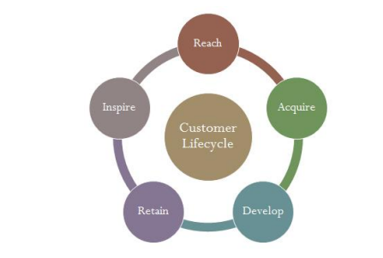

Figure 2.2: Customer lifecycle

**2.7 Effect of Customer Relationship**

Management on Customer Satisfaction Customer Relationship Management (CRM) is a method to attract, to maintain and to improve customer satisfaction and strengthen relationships with customer (Tung, 1997). Furthermore, Customer Relationsip Management (CRM) provides data and information relating to customers, such as in shopping behavior, habits in consuming products, and others (Agrawal, 2004). These data and information are used to improve understanding how to communicate with customers in order to create value and customer satisfaction (Agrawal, 2004). From the above description, it can be concluded that customer relationship management influence customer satisfaction. In other words, the better customer relationship management, the higher the level of customer satisfaction is. Management on Customer Loyalty Customer relationsip Management (CRM) is a strategy focusing on creating customer satisfaction and long-term relationships by integrating several functional areas of the company to achieve competitive advantage (Payne and Frow, 2005; Indah and Dewi, 2013; Chang, 2007; Nguyen, Sherif, and Newby, 2007). Findings of researches conducted by Ardiyhanto (Ardiyhanto, 2011) and Ariyanti (Ariyanti, 2006) show that there are significantly customer relationship management on customer loyalty. This means that the better implementation of CRM in a business unit, it had a positive impact on customer loyalty. Therefore, CRM’s applications allow companies to leverage information from all points of the box with the customer, whether it is via web, call center, or through marketing and servicing staff in the field. Based on the above description, it can be concluded that the better customer relationship management program implemented by the company, the more customers to be loyal to the products/ services produced by the company.

**2.8 Effect of Satisfaction on Customer Loyalty**

Parasuraman in Lupiyoadi (Lupiyoadi, 2011, p. 182) states that it is the feeling of satisfaction after evaluating the product experience. Lupiyoadi also added that in the banking industry, customers satisfy has great potential to become loyal, so it will be a loyal customer who will use all bank products. The higher Customer confidence will increase the love of the bank's customers, and of course, customers will be more like the product of the bank. Complacency customers to guarantee the service will also make customers believe that these brands are the best, and it maybe even customers would recommend bank products to the general public. The higher the level of customer satisfaction, the more it will increase customer loyalty.

**2.9 Indirect effect of Customer Relationship Management on Customer Loyalty through Customer Satisfaction**

Basically, sense of satisfaction and dissatisfaction of customers is the difference between expectations and perceived performance. Thus, understanding the customer satisfaction means that the performance of the goods or services received by consumers is at least equal to their expected. To create customer satisfaction, the companies that engaged in the service should be able to offer a value to gain more customers and also have the ability to maintain customer loyalty. Then through a customer relationship management program that is good and right, it is expected customers will be loyal; of course, when customers quite satisfied. In other words, customer relationship management will have an effect on customer loyalty is only when such customers can be satisfied.

**2.10 Value creation process**

There is core concept of CRM to deliver the value to consumers. The value perception of customers is defined by benefits that customers get from products or services, and the sacrifices made to experiences these benefits. Hence the value can be described as an equation.

$Value=Benefits / Sacrifices.$

As the equation of value, there are two methods to increase customer’s perceived value, by increasing the benefits they have experienced or by decreasing the sacrifices they made. (Buttle 2009, 186-187.) When speaking about value creation, it is to be noted that the value is not only added solely to customer or to a company. What value creation process strives to find, are the perfect solutions to gain mutual benefit. Payne (2006) states, that creating value to a customer can be considered to be one of the most important factors in achieving a competitive advantage. However, it is not often agreed on what makes the value for customer. Thus, companies should clearly know what the value is, that they want to deliver to customers from different segments, and also have a plan on how they could actually manage to deliver it. The main aim of CRM is to establish the mutually beneficial relationship with customers. The approach to reach this goal is to customize the value proposition to acquire and retain targeted consumers. Therefore, the value delivery is the main duty for marketing people. Marketing mix is the most useful tool to analyses value proposition, as the well-known marketing mix composed by 4Ps: product, price, promotion and place. Moreover, this approach is widely applied in many business sectors, and this is a fundamental approach to analyses value creating for consumers. Nowadays, service is paid high attention from the marketing point of view. Hence additional 3Ps (people, physical evidence and process) are added to create more value to consumers. (Buttle 2009, 186-197).

**CHAPTER THREE**

**RESEARCH METHODOLOGY**

**3.1 Introduction**

This chapter of the research work explicitly and objectively, within the perimeters of the subject’s focus, deals with how the research work would be executed. It has mainly relied on the philosophical stance and the research problem to guide on the methodological choice.

3.2 Research Design

A research design, according to Onwumere (2019), is a type of framework that leads and influences the researcher on their research knowledge, skills and understanding of his or her investigation and analyses. A research design is the procedures for collecting, analyzing, interpreting and reporting data in research studies’ (Creswell & Plano Clark 2007, p.58). It is the overall plan for connecting the conceptual research problems with the pertinent (and achievable) empirical research. In other words, the research design sets the procedure on the required data, the methods to be applied to collect and analyze this data, and how all of this is going to answer the research question (Grey, 2014). According to Robson (2002), there are three possible forms of research design: exploratory, descriptive and explanatory. Explanatory research is a research method that explores why something occurs when limited information is available. It can help you increase your understanding of a given topic, ascertain how or why a particular phenomenon is occurring, and predict future occurrences. Explanatory research can also be explained as a “cause and effect” model, investigating patterns and trends in existing data that haven’t been previously investigated.

3.2.1. Philosophical Stance

Scientific research philosophy is a system of the researcher’s thought, following which new, reliable knowledge about the research object is obtained. Philosophical assumptions/paradigms are described as a cluster of beliefs that dictates what should be studied, how research should be done and how the results should be interpreted (Bryman, 2008). In short, they are generally orientations about the world the researcher holds (Creswell, 2009). As a philosophy, positivism adheres to the view that only “factual” knowledge gained through observation (the senses), including measurement, is trustworthy. In positivism studies the role of the researcher is limited to data collection and interpretation in an objective way. In other words, the researcher is an objective analyst and she distances herself from personal values in conducting the study. In these types of studies research findings are usually observable and quantifiable. Positivism often involves the use of existing theory to develop hypotheses to be tested during the research process. Positivist researchers tend to use highly structured research methodology in order to allow the replication of the same study in the future.

**3.3. Data Collection**

A structured questionnaire is a type of interview in which the interviewer asks a particular set of predefined questions. Questions are planned and created in advance, which means that all respondents are asked the same questions in the same order. Consist of closed or prompted questions with predefined answers. The researcher has to anticipate all possible answers with pre-coded responses. They are used in large interview programs (anything over 30 interviews and more likely over 200 interviews in number) and may be carried out face-to-face, self-completion and over the telephone, or depending on the respondent type, the content of questionnaire and the budget. Advantages include: Can be conducted efficiently by interviewers trained only to follow the instructions on the interview guide or questionnaire; do not require the development of rapport between interviewer and interviewee, and they can produce consistent data that can be compared across a number of respondents. A google search was done to find out the different newspaper companies in Nigeria and just 1 company was selected to make the research unique and based on the company. The stratified random sampling was further be adopted to determine individual respondents. Following the earlier stated sampling technique, the proportional stratified sampling was used to select equal sample of seventy (70) subscribers and readers to be surveyed. Overall, the sample size of this study will be 70. The above sampling technique and sample size was employed in order to have representation of the various readers and subscribers because the population does not constitute a homogenous group (Datta, 2018). The survey was conducted among 70 news readers in Lagos, Nigeria and it lasted two (2) weeks.

**3.4. Data Analysis**

As quantitative data is in the form of numbers, mathematical and statistical analysis of these numbers can lead to establishing some conclusive results. This thesis study adopted the two main Quantitative Data Collection Methods:

Surveys: Traditionally, surveys were conducted using paper-based methods and have gradually evolved into online mediums. Closed-ended questions form a major part of these surveys as they are more effective in collecting quantitative data. The survey makes include answer options which they think are the most appropriate for a particular question. Surveys are integral in collecting feedback from an audience which is larger than the conventional size.

One-on-one Interviews: This quantitative data collection method was also traditionally conducted face-to-face but has shifted to telephonic and online platforms. Interviews offers a researcher the opportunity to gather extensive data from the participants. Quantitative interviews are immensely structured and play a key role in collecting information.

* Face-to-Face Interviews: An interviewer can prepare a list of important interview questions in addition to the already asked survey questions. This way, interviewees provide exhaustive details about the topic under discussion. An interviewer can manage to bond with the interviewee on a personal level which will help him/her to collect more details about the topic due to which the responses also improve. Interviewers can also ask for an explanation from the interviewees about unclear answers.
* Online/Telephonic Interviews: Telephone-based interviews are no more a novelty but these quantitative interviews have also moved to online mediums such as Skype or Zoom. Irrespective of the distance between the interviewer and the interviewee and their corresponding time zones, communication becomes one-click away with online interviews. In case of telephone interviews, the interview is merely a phone call away.
* Computer Assisted Personal Interview: This is a one-on-one interview technique where the interviewer enters all the collected data directly into a laptop or any other similar device. The processing time is reduced and also the interviewers don’t have to carry physical questionnaires and merely enter the answers in the laptop.

Data gotten from the research survey was analyzed and wrangled using Qualtrics to create relationships and answer the research questions.

3.5. Customer research

The research was made in order to find out the overall opinion about the company and the amount of satisfaction among the customers. There were some questions guiding the thesis, such as: what is a good relationship between a company and a customer, how could the relationship be improved, and what makes customers stay with one company and becoming loyal to it, what role can digitization play in profitability of a company.

The questionnaire consisted of 10 questions. Both open- and closed ended questions were used. The first 3 questions were to collect some background information about the interviewee: age group, gender and the length of customer relationship. Another set of questions measured the customer’s commitment, reasons for choosing and reading Complete sport newspaper as source of information and leaving other newspaper. To measure the amount of positive word of mouth and to find out the amount of satisfaction among the customers, it was also asked if the respondent would recommend Complete sport newspaper to their friend. For those who wouldn’t recommend the company to a friend, there was free space given for reasoning the answer. The last part of questionnaire consisted of 11 sentences about Complete sport, each of which the interviewee had to choose one of four options that best suited their opinion. The options for the sentences were “strongly agree”, “agree in some amount”, “disagree in some amount” and “strongly disagree”. The options were explained before the sentences and numbered from 4 being “strongly agree” to 1 “strongly disagree”. Finally, the interviewee was given a possibility to open up their answers or give other feedback. The interviewees were also thanked for their replies.

**CHAPTER FOUR**

* 1. **Results and Discussion**

The first question was about the age distribution of the customers. The question was asked to find out the age differences in news consumption. Our findings suggest that young citizens are more frequent users of online news overall.

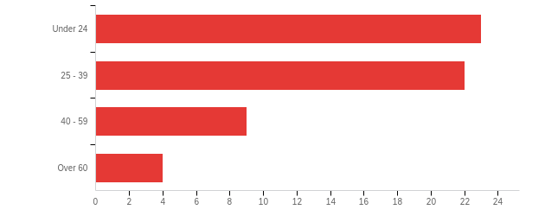

GRAPH 1: Age distribution

Four age groups were defined based on different needs: under 24 years, 25–39, 40–59 and 60 years or more. The age groups represent approximately youngsters, family grounders, middle aged and those close to retirement age and retired. Each group have their own needs, and should be noted in a news paper company. The biggest age group are the youngsters, approximately under 24, Second biggest group is the family grounders. The middle aged and those close to retirement age and retired do not really consume sport news as evident in the graph.

The second question figured out the gender division of the customers. The male gender dominated the research. In total 78 % of the interviewees were men and 22 % women as more men were attuned and open to take part in the survey and research than the opposite gender. In fact, the count of women that were able to partake in the research showed that more women are beginning to watch football and be interested in sport news.

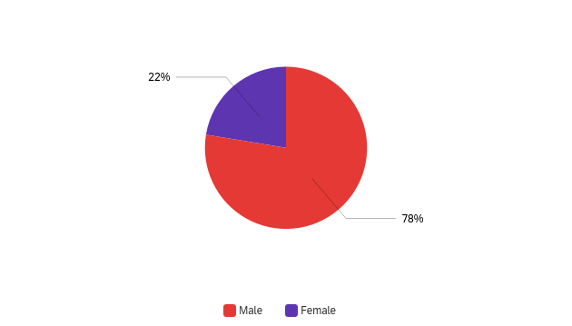

GRAPH 2: Gender distribution

The third and fourth questions attempted to find out if current news was important to the readers and if they actually liked sport news. While 100 % of the respondents was interested in current news, only 10 % of them didn’t like sport news. Over 78 % of the respondents are subscribed to complete sport newspaper as shown in question five, showing loyalty and commitment to the company.

Question six asked what was the length of the relationship years to find out how long the respondents had known and read and was devoted to complete sport newspaper. The purpose of the question was to find out the amount of “win over customers” and loyal customers. The numbers could tell what proportion of the customers has stayed loyal to the company for several years, and the proportion that might be changing their company more often.

Customers were divided into three groups: under 1 year, 1–4 years and over 5 years. The first group symbolized those who had change their subscription within one year. Second group represented those who had already been a customer over one year but who were not yet long-term customers. The third group was the loyal customers who had been customers to the company for already over 5 years.

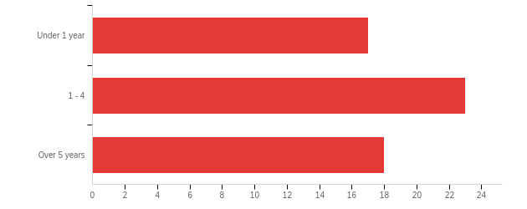

GRAPH 3: Relationship length

The graph shows that over 31 % of the respondents that answered to the questionnaire were long term customers. 29 % of the respondents had stayed in the company for less than one year while about 40 % of customers have stayed within 1 to 4 years showing customer retention. The result is good in that sense that more than half of the customers are retained in the company long term and also new customers are coming in, although some of them might be company switchers who will in some point be lost to a competitor.

In the seventh question the purpose was to find out why customers chose complete sport newspaper. The question was to find out what things most appeal on new customers. Also, by knowing the reasons for customers to choose complete sport, those important things could then be further developed and turned into competitive advantages.

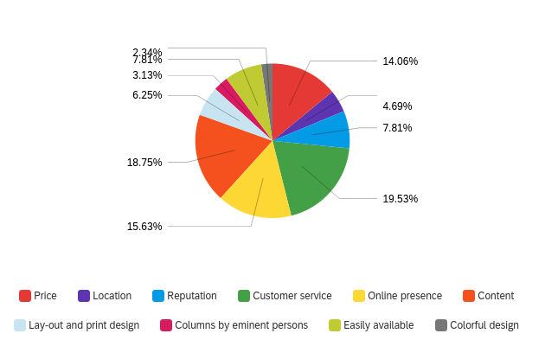

GRAPH 4: Reasons for choosing Complete sport newspaper

Customers were given 10 pre-stated options: Price, Location, Reputation, Customer service, Online presence, Content, Lay-out and print design, Columns by eminent persons, Easily available and Colorful design. Interviewees could choose one to three most suitable alternatives for choosing complete sport newspaper. Customer service, Content, Online presence, and Price were the most important reasons for choosing complete sport newspaper. Customer service seems to be a bigger focus for newspaper company as they are more reliant on consumer revenue. Good customer service means satisfied customers, taking into accounts customers feedback and it reflecting on the mode of operation or style of delivery is key to customers’ retention and this is evident in complete sport newspaper company, as can be seen even from the website interface. More reason, young readers now subscribe more and choose online presence as reason for choosing complete sport newspaper. Customer representatives are also an important thing for a customer, since they give the company the face. When contacting the company for the first time, customers want to have the feeling of being welcomed and wanted. Complete sport newspaper has been in existent for over 10 years and the company has been know for giving good news and content, reason for the good percentage for reputation.

More reasons why customers chose complete sport include columns by eminent persons, lay-out and design, the fact that it is easily available and the location.

The next question was: “If you have previously been a customer of some other newspaper, for what reasons did you decide to switch to Complete Sport? Choose one to three alternatives”. This question was included to find out for what reasons the customers left their previous insurance company. When knowing the most common reasons, it is possible to develop other companies’ weaknesses and shape them into own strengths.

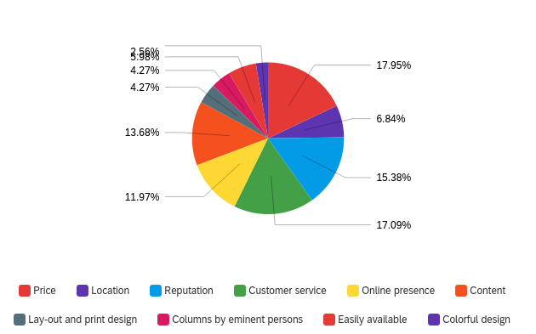

GRAPH 5: Reasons why customer switch to complete sport newspaper

Here however, price seems to be a more motivating factor to switch newspaper subscription. It must be emphasized that complete sport has been able to partner with most sport betting companies in Nigeria, another reason why respondents are more attuned especially, to get good data for making bet predictions.

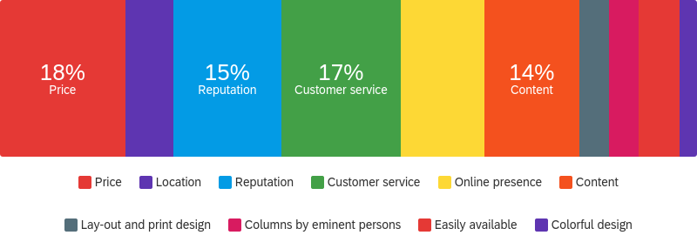

Next question was if customers would recommend Complete sport for their friend. Of the 68 people interviewed, 58 results were true and 56 people responded to this question. 54 responded yes which is amazingly good result. The 2 people who answered No had their reasons, from app not loading well on phone to not being interested in online sport news.

The last question was measuring customers’ opinions about Complete sport newspaper. The sentences were basic things about customer service, the image they had about the company, experiences on checking news on the internet and how important they see some strength areas of Complete sport newspaper company.

Overall, the opinion of Complete sport newspaper from the viewpoint of the readers was great. Most positive viewpoints were using phone to get news, implying online news being the drive for the future. Also, the image of this newspaper to its corresponding customer is positive.

|  |  |  |  |  |  |  |
| --- | --- | --- | --- | --- | --- | --- |
| # | Opinion about Complete Sport Newspaper | strongly agree | agree in some amount | disagree in some amount | strongly disagree | Total Response |
| 1 | Different needs of customers are well observed | 69.23% | 28.85% | 1.92% | 0.00% | 52 |
| 2 | It's worthwhile for me being a customer of Complete Sport newspaper | 67.31% | 28.85% | 3.85% | 0.00% | 52 |
| 3 | Complete Sport newspaper personnel are friendly and professional | 73.08% | 25.00% | 1.92% | 0.00% | 52 |
| 4 | My image of Complete Sport newspaper as a company is positive | 73.08% | 23.08% | 3.85% | 0.00% | 52 |
| 5 | I'm satisfied with Complete Sport newspaper communication | 64.00% | 28.00% | 6.00% | 2.00% | 50 |
| 6 | Complete Sport newspaper appreciates my customership | 60.78% | 31.37% | 5.88% | 1.96% | 51 |
| 7 | Checking news on the internet is easy for me | 73.08% | 25.00% | 1.92% | 0.00% | 52 |
| 8 | Using my phone to browse is easy for me | 84.00% | 16.00% | 0.00% | 0.00% | 50 |

TABLE 1: Customers’ opinion on complete sport newspaper

8 sentences as shown in the table were introduced to the respondents, who were asked to answer on each sentence according to their opinion. The options to choose from were: “strongly agree”, “agree in some amount”, “disagree in some amount” or “strongly disagree”. Usually in questionnaires there is also a neutral option, “can’t say” or “don’t know”, but that was intentionally left out to get an idea if respondents were more positive or negative about the examined factors. Probably due to this, some questions were returned unanswered. 84 % of the customers agree that using a phone to browse is quite easy while 16 % agree in some amount. More so, most customers agree that checking news on the internet is quite easy. This result is quite expected. According to Nigerian communications commission (NCC), Despite losing 13.8 million internet subscriptions between January to May last year due to the government’s suspension of SIM registration and activation between December 2020 and April 2021, the telecom operators in the industry have risen above the challenge to gain a remarkable ground, with mobile network operators taking the lead.

Other positive touch points include that complete sport personnel were friendly and professional and that there was a positive image of complete sport out there on the street. Most customers subscribe to complete sport newspaper to get good first-hand information on news about their favorite football clubs and other sports they are interested in. Bet forecasting results from data gotten from complete sport newspaper has turned out to give more big returns for customers. There are also columns from sport analysts and prominent people that customers look forward to.

On if their needs are well observed and if it’s worthwhile being a customer of complete sport, opinion were varied. From a customer, complete sport has grown over the years and now give us more good sport news content. Now, we have latest current news on club transfers, have a link to bet with cryptocurrency and Olympics news and has grown globally unlike before when it was just central to Nigerian sport news.

Two sentences that had most variance and opinions divisive were the questions whether the customer was satisfied with the communication of Complete sport newspaper and if the company appreciated the customers. Approximately 12 % disagreed in some amount and 4 % strongly disagreed on being satisfied with the communication and if the company appreciated the customers. What was revealed was that some customers would like to feel more connected to complete sport newspaper, or get more feeling of being appreciated. One respondent answered that “Complete sport newspaper hasn’t been in contact with me in any other way than through invoice. It would be nice to be somehow rewarded for loyal customership with a small gift or discount for example.”. Also, another respondent replied that “complete sport newspaper hasn’t really contacted me except with an invoice.” These comments do raise an idea of creating some campaign for rewarding customers. It doesn’t have to be a big gesture by a company to make their customers feel appreciated and special. For example, it could be nice gesture to send some small item with a thank you letter. Also, sending simple birthday messages could go a long way as small gestures to make customers feel closer to the company and create feeling of belonging which again increases commitment.

**CHAPTER FIVE**

**5.0 Conclusion and Recommendation**

The thesis focused on examining the relationships between companies and its customers. Customer retention was highlighted in thesis and it was found out that customer retention in its most efficient form can actually be more profitable for the company than acquiring new customers. It was noted that with the help of CRM it is easy for the companies to acquire certain types of customers, from who those with best value offered and received can be separated. These selected customers can then be more focused on and their interests served with care. It was discussed that trust in a relationship together with shared values equal commitment. Committed relationship by both parties is the ideal situation which should be pursued. When commitment is achieved, the relationship is wanted to retain by both parties and the parties are also willing to put more effort on the relationship. This way the relationship can be retained also when facing difficulties.

The questionnaire was designed according to the theory part to find out reasons for customers to switch their newspaper company and subscribing to a particular newspaper. It was found out that the price is not the only factor when comparing newspaper companies. When customers had changed their newspaper companies, the most common reasons were price (18 %), customer service (17 %), content (14 %), Reputation (15 %) and online presence (12 %). The four most important factors for customers to choose complete sport newspaper were customer service (19.5 %), content (18.7 %), price (14 %) and online presence (15.6 %). 54 out of 56 customers answered they would recommend complete sport newspaper for their friend. The result is amazingly good, and shows that the customers in general are very satisfied with complete sport. What was noticed was the need to improve online readership as that accounted for about 73 % and over 84 % of respondents insist, they prefer accessing news information through the phone.

The thesis answered to the questions introduced at the beginning of the process. What was interesting to learn, were the different factors affecting and influencing customer behavior. It is not only the price that affects customer’s choice of service provider, but remarkably lot it is up to other things, such as news accessibility on phone, internet availability, customer service and needs of customers being taken into consideration that increase customer retention through satisfaction and commitment.

Partnering with complete sport, researchers can examine the effect of customer relationship management on revenue of a newspaper. This should be done by expanding the respondent size and perhaps cover more geological locations. But this could also lead to interviewing staffs of the company and maybe perhaps getting official company’s financial data. This is recommended for further research.

In conclusion, businesses should focus on retaining the customers, who bring value for the company, and whom the company can offer value for. Successful relationship requires both parties to be willing to put an effort for retaining the relationship. This way commitment is achieved, which again creates the profit. Customer acquisition an important thing for any company, but at the end it is useless unless the most important customers can be retained.

REFERENCES

Adrian (2006). Handbook of CRM: Achieving excellence in Customer Management.

Anderson and Weitz (1992) The Use of pledges to build and sustain commitment in distribution channels [Online] Available from: <https://www.researchgate.net/publication/328647375_Is_the_theory_of_trust_and_commitment_in_marketing_relationships_incomplete> [Accessed 25 July 2022].

Ang and Buttle (2006). Customer Retention Management Processes: A quantitative study. European Journal of Marketing.

Apte et al., (2002): ‘Business Applications of Data Mining’, Communications of the ACM, 45 (August), pp.49-53 [Online] Available from: <https://www.researchgate.net/publication/220426168_Business_applications_of_data_mining> [Accessed 27 July 2022]

Berry and Parasuraman. 1991. Zeithaml 1998 in Ranaweera, C. and Neely, A. 2003. Some Moderating Effects on The Service Quality-Customer Retention Link. International Journal of Operations and Production Management. Volume 23. Issue 2, 2003.

Buttle (1996). Relationship Marketing: Theory and Practice. SAGE Publications Ltd. UK.

Buttle, F. (2004). Customer relationship management: concepts and tools. Oxford: Elsevier Butterworth-Heinemann.

Buttle (2009) Customer Relationship Management: Concepts and Technologies. Second edition.

[https://www.completesports.com/](https://www.completesports.com/%20%20)  [Accessed July 28 2022]

Coyles and Gokey (2005) Customer retention is not enough. Journal of Consumer Marketing. Volume 22. Issue 2, 2005.

Customer retention management processes: A quantitative study. Emerald Group Publishing Ltd. European Journal of Marketing. Volume 40. Issue 1/2, 2006.

Dwyer et al., 1987. Developing Buyer-Seller Relationships. The Journal of Marketing. Volume 51. Number 2, 1987.

Gerson (1998) Beyond Customer Service: Keeping Customers for Life [Online] Available from: <https://archive.org/details/beyondcustomerse0000gers> [Accessed July 30 2022]

Harvard Business Review (2011) Increasing Customer Loyalty.

Hogan et al., 2003. What is the True Value of a Lost Customer? SAGE. Journal of Science Research. Volume 5. Number 3, 2005.

Kaltcheva et al 2013. Do Customer Relationships Mitigate or Amplify Failure Responses? Journal of Business Research. Volume 66. Issue 4, 2013.

Kumar and Petersen (2012) Statistical Methods in Customer Relationship Management. Wiley.

Leventhal (2006) Customer Loyalty, Retention, and Customer Relationship Management. Emerald Group Publishing Ltd.

Payne, A. and Frow, P. (2013). Strategic customer management: integrating CRM and relationship marketing. Cambridge: Cambridge University Press, p. 211.

Payne, A. (2005). Handbook of CRM: achieving excellence through customer management. Oxford: Elsevier Butterworth-Heinemann

Payne, A. and Frow, P. (2005). A strategic framework for customer relationship management. Journal of Marketing, 69 (October), 167–76

Wright et al., (2002): ‘The CRM imperative: practice vs. theory in the telecommunications industry’, Journal of Database Marketing, vol. 9, no. 4, pp. 339-49

APPENDIX

CONSENT FORM

MANAGING CUSTOMER RELATIONSHIP: A CASE STUDY OF COMPLETE SPORT NEWSPAPER.

This consent form will be given to you with Participant Information sheet. Please ensure that you have read and understood the information contained in the Participant Information Sheet and ask any questions before you sign this form.

If you are happy to take part in this interview, please sign and date the form. You will be given a copy to keep for your records.

* I have read and understood the information in the Participant Information Sheet which I have been given to read before asked to sign this form;
* I have been given the opportunity to ask questions about the study;
* I have had my questions answered satisfactorily by the research team;
* I agree that anonymized quotes may be used in the final Report of this study;
* I understand that my participation is voluntary and that I am free to withdraw at any time until the data has been anonymized, without giving a reason;
* I agree to take part in the research

Researcher’s Name: Grace Ibrahim

Date: August 2022

ETHICS FORM

|  |  |
| --- | --- |
| **Section 1: Applicant Details** | |
| First Name | GRACE YUSUF |
| Last Name | IBRAHIM |
| Faculty | FBL |
| Department | INTERNATIONAL MANAGEMENT |
| Co-researcher Names  (internal and external)  Please include names, institutions and roles. If there are no co-researchers, please state N/A. |  |
| Is this application for a staff or a student? | Student |
| Student Course details | Masters |
| Name of Director of Studies / Supervisor | MILDRED BROWN-HOUSTON |
| Comments from Director of Studies / Supervisor  *For student applications, supervisors should ensure that all of the following are satisfied before the study begins:*   * *The topic merits further research;* * *The student has the skills to carry out the research;* * *The participant information sheet is appropriate; and procedures for recruitment of research participants and obtained informed consent are appropriate.*   *The supervisor must add comments here. Failure to do so will result in the application being returned* | |
| My answer is yes to all the above but will need to revise research objectives and research questions before final submission for better focus and clarity. | |

|  |  |
| --- | --- |
| **Section 2: Project** | |
| **Section 2:1 Project details** | |
| Full Project Title | |
| MANAGING CUSTOMER RELATIONSHIP: A CASE STUDY OF COMPLETE SPORT NEWSPAPER. | |
| **Project Dates**  These are the dates for the overall project, which may be different to the dates of the field work and/or empirical work involving human participants. | |
| Project Start Date | 04/07/2022 |
| Project End Date | 15/09/2022 |
| **Dates for work requiring ethical approval**  You must allow **at least 6 weeks** for an initial decision, plus additional time for any changes to be made. | |
| Start date for work requiring ethical approval | 31/08/2022 |
| End date for work requiring ethical approval | 13/09/2022 |
| How is the project funded?  (e.g. externally, internally, self-funded, not funded – including scholarly activity)  Please provide details.. | |
| Self-funded | |

|  |  |
| --- | --- |
| Is external ethics approval needed for this research? | No |
| If Yes please provide the following:  For NHS Research please provide a copy of the letter from the HRA granting full approval for your project together with a copy of your IRAS form and supporting documentation, including reference numbers.  Where review has taken place elsewhere (e.g. via another university or institution), please provide a copy of your ethics application, supporting documentation and evidence of approval by the appropriate ethics committee. | |
| Click or tap here to enter text. | |
| **Section 2:2 Project summary** | |
| Please provide a concise summary of the project, including its aims, objectives and background. (maximum 400 words)  Please describe in non-technical language what your research is about. Your summary should provide the committee with sufficient detail to understand the nature of the project, its rationale and ethical context. | |
| At the present time when the majority of companies are still dealing with impacts of the economic crisis, new solutions on how to restructure companies and keep customers are being searched. There are a lot of options how to solve it. This article deals in detail the utilization of technology and business strategy using customer relationship management (CRM) and more precisely on customer retention. Several newspaper companies have been knocked out of the industry due to lack of proper understanding and management of customers’ relationship.  A newspaper business is a competitive one and it is interesting to start to find reasons customers prefer one and could switch subscriptions. The significant impact of this study is to serve as a verifiable platform for newspaper industry. The adoption of technical and adequate innovations of this research could possibly result in phenomenal and exponential growth in the market dominance. Similarly, the result of analysis of customers relationship trend will impact the newspaper companies to make informed decisions, and hence enhance their decision-making power to further advance their course and actions and achieve greater organizational goals and objectives.  The aim of the study was to investigate the effect of customer relationship management on complete sport newspaper. To achieve this aim, the following objectives have been put forward.  1. To find out the overall opinion of customers on Complete sport newspaper  2. To examine the amount of satisfaction among Complete sport newspaper readers | |
| What are the research questions the project aims to answer? (maximum 200 words) | |
| The questions guiding this research includes:   1. What is the overall opinion of customers on Complete sport newspaper 2. How could the relationship be improved, and what makes customers stay with one company and become loyal to it 3. What is the amount of satisfaction among Complete sport newspaper readers 4. What is the impact of digitilization on Complete sport newspaper | |
| Please describe the research methodology for the project. (maximum 250 words) | |
| A customer research survey was done on Complete sport newspaper readers. The research was made in order to find out the overall opinion about the company and the amount of satisfaction among the customers. There were some questions guiding the thesis, such as: what is a good relationship between a company and a customer, how could the relationship be improved, and what makes customers stay with one company and becoming loyal to it, what role can digitization play in profitability of a company.  The questionnaire consisted of 10 questions. Both open- and closed ended questions were used. The first 3 questions were to collect some background information about the interviewee: age group, gender and the length of customer relationship. Another set of questions measured the customer’s commitment, reasons for choosing and reading Complete sport newspaper as source of information and leaving other newspaper. To measure the amount of positive word of mouth and to find out the amount of satisfaction among the customers, it was also asked if the respondent would recommend Complete sport newspaper to their friend. For those who wouldn’t recommend the company to a friend, there was free space given for reasoning the answer. The last part of questionnaire consisted of 11 sentences about Complete sport, each of which the interviewee had to choose one of four options that best suited their opinion. The options for the sentences were “strongly agree”, “agree in some amount”, “disagree in some amount” and “strongly disagree”. | |

|  |  |
| --- | --- |
| **Section 3: Human Participants** | |
| Does the project involve human participants or their data?  *If not, please proceed to Section 5: Data Collection, Storage and Disposal, you do not need to complete sections 3-4.* | Yes |
| **Section 3.1: Participant Selection** | |
| Who are your participants? | |
| Complete Sport newspaper subscribers and readers | |
| Will you be recruiting students as research participants who are from outside your faculty and/or from multiple faculties?  If you plan to recruit student participants from across UWE (rather than solely from your home faculty) your ethics application will be reviewed by UREC instead of the FREC. | No |
| Please explain the steps you will take to select your participant sample. | |
| A google search was done to find out the different newspaper companies in Nigeria and just 1 company was selected to make the research unique and based on the company. The stratified random sampling will further be adopted to determine individual respondents. | |
| Please explain how you will determine the sample size. | |
| Following the earlier stated sampling technique, the proportional stratified sampling will be used to select equal sample of seventy (70) subscribers and readers to be surveyed. Overall, the sample size of this study will be 70. The above sampling technique and sample size will be employed in order to have representation of the various employee because the population does not constitute a homogenous group (Datta, 2018). | |
| Please tell us if any of the participants in your sample are vulnerable, or are potentially vulnerable and explain why they need to be included in your sample.  NB: Please do not feel that including vulnerable, or potentially vulnerable participants will be a bar to gaining ethical approval.  Although there may be some circumstances where it is inappropriate to include certain participants, there are many projects which need to include vulnerable or potentially vulnerable participants in order to gain valuable research information.  This particularly applies to projects where the aim of the research is to improve quality of life for people in these groups.  Vulnerable or potentially vulnerable participants that you **must** tell us about:   * Children under 18 * Adults who are unable to give informed consent * Anyone who is seriously ill or has a terminal illness * Anyone in an emergency or critical situation * Anyone with a serious mental health issue that might impair their ability to consent, or cause the research to distress them * Young offenders and prisoners * Anyone with a relationship with the researcher(s) * The elderly | |
| Click or tap here to enter text. | |
| **Section 3.2: Participant Recruitment and Inclusion** | |
| How will you contact potential participants? Please select all that apply. | |
| ☐ Advertisement  ☒ Emails  ☒ Face-to-face approach  ☐ Post  ☒ Social media  ☐ Telephone calls  ☐ Other  If Other, please specify: Click or tap here to enter text. | |
| What recruitment information will you give potential participants?  Please ensure that you include a copy of the initial information for participants with your application.  [Research Template Participant Information Sheet](https://docs.uwe.ac.uk/ou/Communications/_layouts/15/download.aspx?SourceUrl=https://docs.uwe.ac.uk/ou/Communications/Documents/GDPR/guidance_on_participant_information_sheets%20FINAL.docx)  [Research Template Privacy Notice](https://docs.uwe.ac.uk/ou/Communications/_layouts/15/download.aspx?SourceUrl=https://docs.uwe.ac.uk/ou/Communications/Documents/GDPR/guidance_on_research_participant_privacy_notice%20FINAL.docx) | |
| Recruitments notice will be sent by emails and social media posting. The overview including aims and objectives of the research survey will be shared with participants. The amount of questions to be answered eight (8) and the time limit, 30 minutes. Also privacy notice that information shared is private | |
| How will you gain informed written consent from the participants?  Please ensure that you include a copy of the participant information sheet and consent form with your application.  [Research Template Consent form](https://docs.uwe.ac.uk/ou/Communications/_layouts/15/download.aspx?SourceUrl=https://docs.uwe.ac.uk/ou/Communications/Documents/GDPR/GDPR%20consent%20form%20FINAL.docx)  [Research Template Privacy Notice](https://docs.uwe.ac.uk/ou/Communications/_layouts/15/download.aspx?SourceUrl=https://docs.uwe.ac.uk/ou/Communications/Documents/GDPR/guidance_on_research_participant_privacy_notice%20FINAL.docx) | |
| Consent form will be sent and expected to be signed before the participants can undertake the survey. | |
| What arrangements are in place for participants to withdraw from the study? | |
| The participants are guaranteed that they can withdraw anytime they chose to once they feel uncomfortable with the study | |

|  |  |
| --- | --- |
| **Section 4: Human Tissue** | |
| Does the project involve human tissue? | No |
| *If you answer ‘No’ to the above question, please go to Section 5*  Please describe the research methodology that you will use.  This should include an explanation of why human tissue is required for the project and a description of the information that you and the research team will have access to about the participants/donors. | |
| Click or tap here to enter text. | |
| Please describe how you propose to obtain/collect, process, securely store and dispose of the human tissue. | |
| Click or tap here to enter text. | |
| Please explain if and how samples will be anonymised.  Where samples are not anonymised, please explain how confidentiality will be maintained, including how this information will be securely and appropriately stored and disposed of. | |
| Click or tap here to enter text. | |

|  |
| --- |
| **Section 5: Data Collection, Storage and Disposal** |
| Research undertaken at UWE by staff and students must be GDPR compliant. For further guidance see [Research and GDPR compliance](https://intranet.uwe.ac.uk/whats-happening/sites/gdpr/updates/pages/research-and-gdpr-compliance-update-08-may-2019.aspx)  ☒Please confirm that you have included the UWE Privacy Notice with the Participant Information Sheet and Consent Form  **☒** By ticking this box, I confirm that I have read the [Data Protection Research Standard](https://docs.uwe.ac.uk/ou/Communications/_layouts/15/download.aspx?SourceUrl=https://docs.uwe.ac.uk/ou/Communications/Documents/GDPR/GDPR%20Research%20Governance%20Standard%20FINAL.docx), understand my responsibilities as a researcher and that my project has been designed in accordance with the Standard. |

|  |
| --- |
| **Section 5.1 Data Collection and Analysis** |
| Which of these data collection methods will you be using? Please select all that apply. |
| ☒ Interviews  ☒ Questionnaires/surveys  ☐ Focus groups  ☐ Observation  ☐ Secondary sources  ☐ Clinical measurement  ☐ Digital media  ☐ Sample collection  ☐ Other  If Other, please specify: Click or tap here to enter text.  Please note that online surveys must only be administered via [Qualtrics](https://www.qualtrics.com/uk/)  Please ensure that you include a copy of the questionnaire/survey with your application. |
| What type of data will you be collecting? |
| ☒ Quantitative data  ☐ Qualitative data |
| Please describe the data analysis and data anonymisation methods. |
| Qualtrics will be used in analyzing the questions and illustrating the results with graphs and tables. |
| **Section 5.2 Data Storage, Access and Security** |
| Where will you store the data? Please select all that apply. |
| ☐ H:\ drive on UWE network  ☒ Restricted folder on S:\ drive  ☐ Restricted folder on UWE OneDrive  ☐ Other (including secure physical storage)  If Other, please specify: Click or tap here to enter text. |
| Please explain who will have access to the data. |
| I alone will have access to this data |
| Please describe how you will maintain the security of the data and, where applicable, how you will transfer data between co-researchers. |
| There will be no transfer of data hence security of data maintained securedly on s:\ drive. |
| **Section 5.3 Data Disposal** |
| Please explain when and how you will destroy personal data. |
| Data will be deleted at end of dissertation |

|  |  |  |
| --- | --- | --- |
| **Section 6: Other Ethical Issues** | | |
| What risks, if any, do the participants (or donors, if your project involves human tissue) face in taking part in the project and how will you address these risks? | | |
| There are no risks involved, and more so no private questions are to be asked | | |
| Are there any potential risks to researchers and any other people as a consequence of undertaking this project that are greater than those encountered in normal day-to-day life?  For further information, see [guidance on safety of social researchers](https://docs.uwe.ac.uk/sites/health-and-safety/_layouts/15/download.aspx?SourceUrl=https://docs.uwe.ac.uk/sites/health-and-safety/Documents/G017_Social_Researchers.docx). | | |
| No there are none | | |
| How will the results of the project be reported and disseminated? Please select all that apply. | | |
| ☐ Peer reviewed journal  ☐ Conference presentation  ☐ Internal report  ☒ Dissertation/thesis  ☒ Written feedback to participants  ☐ Presentation to participants  ☐ Report to funders  ☐ Digital media  ☐ Other  If Other, please specify: Click or tap here to enter text. | | |
| Does the project involve research that may be considered to be security sensitive?  For further information, see [UREC guidance for security sensitive research.](http://www1.uwe.ac.uk/research/researchethics/guidance.aspx) | No | |
| Please provide details of the research that may be considered to be security sensitive. | | |
| Click or tap here to enter text. | | |
| Does the project involve conducting research overseas? | | Yes |
| Have you received approval from your Head of Department/Associate Dean (RKE) and is there sufficient insurance in place for your research overseas? | | Not applicable |
| Please provide details of any ethical issues which may arise from conducting research overseas and how you will address these. | | |
| There are none and consent form will be duly signed before commencement of the survey | | |

|  |
| --- |
| **Section 7: Supporting Documentation** |
| Please ensure that you provide copies of all relevant documentation, otherwise the review of your application will be delayed. Relevant documentation should include a copy of:    • The research proposal or project design.  • The participant information sheet and consent form, including a UWE privacy notice.  • The questionnaire/survey.  • External ethics approval and any supporting documentation.    Please clearly label each document - ensure you include the applicant's name, document type and version/date (e.g. Joe Bloggs - Questionnaire v1.5 191018). |

|  |
| --- |
| **Section 8: Declaration** |
| ☒ By ticking this box, I confirm that the information contained in this application, including any accompanying information is, to the best of my knowledge, complete and correct. I have attempted to identify all risks related to the research that may arise in conducting this research and acknowledge my obligations and the right of the participants.  Name: IBRAHIM GRACE YUSUF  Date: 31/08/2022 |

**This form should be submitted electronically to the Research Ethics Admin Team:** [**researchethics@uwe.ac.uk**](mailto:researchethics@uwe.ac.uk) **and email copied to the Supervisor/Director of Studies where applicable, together with all supporting documentation (research proposal, participant information sheet, consent form etc).**

**Please provide all the information requested and justify where appropriate.**

**For further guidance, please see** [**http://www1.uwe.ac.uk/research/researchethics**](http://www1.uwe.ac.uk/research/researchethics) **(applicants’ information)**

Default Report  
*MANAGING CUSTOMER RELATIONSHIP: A CASE STUDY OF COMPLETE SPORT NEWSPAPER.*  
**September 15th 2022, 8:48 pm BST**

**0 - This consent form and the Participant Information sheet has been attached. Please ensure that you ha**

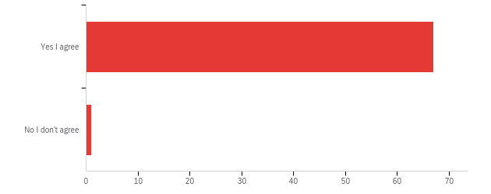

|  |  |  |  |  |  |  |  |
| --- | --- | --- | --- | --- | --- | --- | --- |
| # | Field | Minimum | Maximum | Mean | Std Deviation | Variance | Count |
| 1 | This consent form and the Participant Information sheet has been attached. Please ensure that you ha | 1.00 | 2.00 | 1.01 | 0.12 | 0.01 | 68 |

|  |  |  |  |
| --- | --- | --- | --- |
| # | Answer | % | Count |
| 1 | Yes I agree | 98.53% | 67 |
| 2 | No I don't agree | 1.47% | 1 |
|  | Total | 100% | 68 |

**Q1 - Age group:**

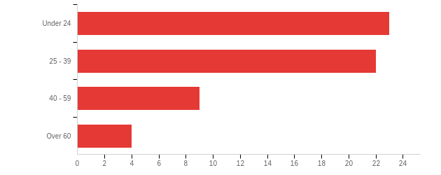

|  |  |  |  |  |  |  |  |
| --- | --- | --- | --- | --- | --- | --- | --- |
| # | Field | Minimum | Maximum | Mean | Std Deviation | Variance | Count |
| 1 | Age group: | 1.00 | 4.00 | 1.90 | 0.90 | 0.82 | 58 |

|  |  |  |  |
| --- | --- | --- | --- |
| # | Answer | % | Count |
| 1 | Under 24 | 39.66% | 23 |
| 2 | 25 - 39 | 37.93% | 22 |
| 3 | 40 - 59 | 15.52% | 9 |
| 4 | Over 60 | 6.90% | 4 |
|  | Total | 100% | 58 |

**Q2 - Gender:**

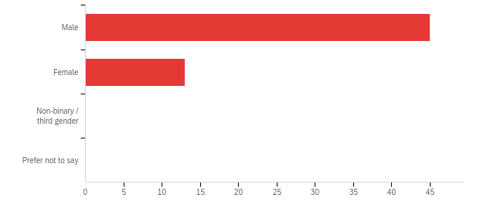

|  |  |  |  |  |  |  |  |
| --- | --- | --- | --- | --- | --- | --- | --- |
| # | Field | Minimum | Maximum | Mean | Std Deviation | Variance | Count |
| 1 | Gender: | 1.00 | 2.00 | 1.22 | 0.42 | 0.17 | 58 |

|  |  |  |  |
| --- | --- | --- | --- |
| # | Answer | % | Count |
| 1 | Male | 77.59% | 45 |
| 2 | Female | 22.41% | 13 |
| 3 | Non-binary / third gender | 0.00% | 0 |
| 4 | Prefer not to say | 0.00% | 0 |
|  | Total | 100% | 58 |

|  |  |  |
| --- | --- | --- |
| # | Gender: | Mean |
| 1 | Gender: | 1 |

**Q3 - Is current news and information important to you?**

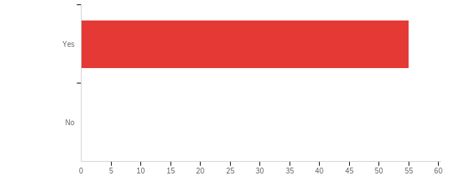

|  |  |  |  |  |  |  |  |
| --- | --- | --- | --- | --- | --- | --- | --- |
| # | Field | Minimum | Maximum | Mean | Std Deviation | Variance | Count |
| 1 | Is current news and information important to you? | 1.00 | 1.00 | 1.00 | 0.00 | 0.00 | 55 |

|  |  |  |  |
| --- | --- | --- | --- |
| # | Answer | % | Count |
| 1 | Yes | 100.00% | 55 |
| 2 | No | 0.00% | 0 |
|  | Total | 100% | 55 |

**Q4 - Do you like sport news**

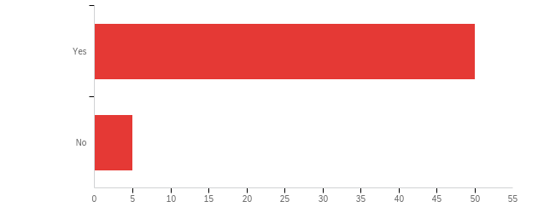

|  |  |  |  |  |  |  |  |
| --- | --- | --- | --- | --- | --- | --- | --- |
| # | Field | Minimum | Maximum | Mean | Std Deviation | Variance | Count |
| 1 | Do you like sport news | 1.00 | 2.00 | 1.09 | 0.29 | 0.08 | 55 |

|  |  |  |  |
| --- | --- | --- | --- |
| # | Answer | % | Count |
| 1 | Yes | 90.91% | 50 |
| 2 | No | 9.09% | 5 |
|  | Total | 100% | 55 |

**Q5 - Are you a subscriber of Complete Sport newspaper**

|  |  |  |  |
| --- | --- | --- | --- |
| # | Answer | % | Count |
| 1 | Yes | 78.95% | 45 |
| 2 | No | 21.05% | 12 |
|  | Total | 100% | 57 |

|  |  |  |  |  |  |  |  |
| --- | --- | --- | --- | --- | --- | --- | --- |
| # | Field | Minimum | Maximum | Mean | Std Deviation | Variance | Count |
| 1 | Are you a subscriber of Complete Sport newspaper | 1.00 | 2.00 | 1.21 | 0.41 | 0.17 | 57 |

|  |  |  |  |
| --- | --- | --- | --- |
| # | Answer | % | Count |
| 1 | Yes | 78.95% | 45 |
| 2 | No | 21.05% | 12 |
|  | Total | 100% | 57 |

**Q6 - Relationship years**

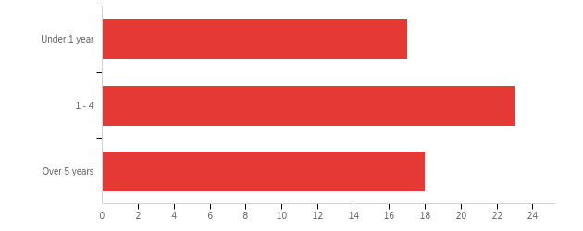

|  |  |  |  |  |  |  |  |
| --- | --- | --- | --- | --- | --- | --- | --- |
| # | Field | Minimum | Maximum | Mean | Std Deviation | Variance | Count |
| 1 | Relationship years | 1.00 | 3.00 | 2.02 | 0.78 | 0.60 | 58 |

|  |  |  |  |
| --- | --- | --- | --- |
| # | Answer | % | Count |
| 1 | Under 1 year | 29.31% | 17 |
| 2 | 1 - 4 | 39.66% | 23 |
| 3 | Over 5 years | 31.03% | 18 |
|  | Total | 100% | 58 |

**Q7 - Why do you prefer Complete Sport newspaper? Choose one to three alternatives**

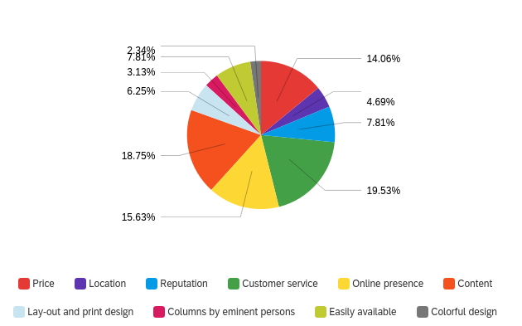

|  |  |  |  |
| --- | --- | --- | --- |
| # | Answer | % | Count |
| 1 | Price | 14.06% | 18 |
| 2 | Location | 4.69% | 6 |
| 3 | Reputation | 7.81% | 10 |
| 4 | Customer service | 19.53% | 25 |
| 5 | Online presence | 15.63% | 20 |
| 6 | Content | 18.75% | 24 |
| 7 | Lay-out and print design | 6.25% | 8 |
| 8 | Columns by eminent persons | 3.13% | 4 |
| 9 | Easily available | 7.81% | 10 |
| 10 | Colorful design | 2.34% | 3 |
|  | Total | 100% | 128 |

**Q8 - If you have previously been a customer of some other newspaper, for what reasons did you decide to switch to Complete Sport? Choose one to three alternatives**

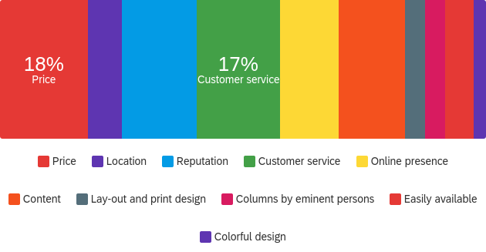

|  |  |  |  |
| --- | --- | --- | --- |
| # | Answer | % | Count |
| 1 | Price | 17.95% | 21 |
| 2 | Location | 6.84% | 8 |
| 3 | Reputation | 15.38% | 18 |
| 4 | Customer service | 17.09% | 20 |
| 5 | Online presence | 11.97% | 14 |
| 6 | Content | 13.68% | 16 |
| 7 | Lay-out and print design | 4.27% | 5 |
| 8 | Columns by eminent persons | 4.27% | 5 |
| 9 | Easily available | 5.98% | 7 |
| 10 | Colorful design | 2.56% | 3 |
|  | Total | 100% | 117 |

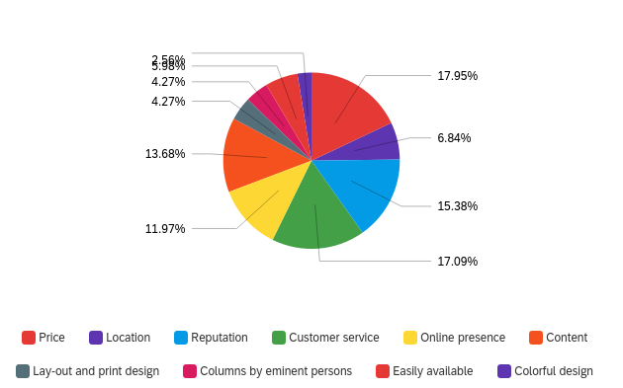

**Q9 - Would you recommend Complete Sport newspaper to your friend?**

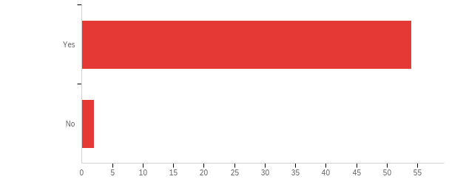

|  |  |  |  |  |  |  |  |
| --- | --- | --- | --- | --- | --- | --- | --- |
| # | Field | Minimum | Maximum | Mean | Std Deviation | Variance | Count |
| 1 | Would you recommend Complete Sport newspaper to your friend? | 1.00 | 2.00 | 1.04 | 0.19 | 0.03 | 56 |

|  |  |  |  |
| --- | --- | --- | --- |
| # | Answer | % | Count |
| 1 | Yes | 96.43% | 54 |
| 2 | No | 3.57% | 2 |
|  | Total | 100% | 56 |

**Q10 - Please provide answer to the statements**

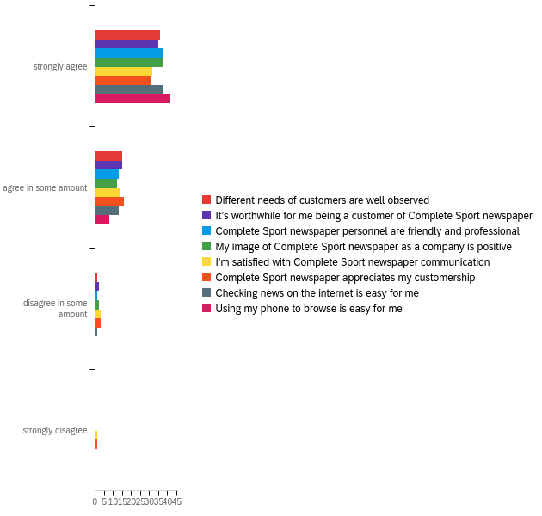

|  |  |  |  |  |  |  |  |
| --- | --- | --- | --- | --- | --- | --- | --- |
| # | Field | Minimum | Maximum | Mean | Std Deviation | Variance | Count |
| 1 | Different needs of customers are well observed | 1.00 | 3.00 | 1.33 | 0.51 | 0.26 | 52 |
| 2 | It’s worthwhile for me being a customer of Complete Sport newspaper | 1.00 | 3.00 | 1.37 | 0.56 | 0.31 | 52 |
| 3 | Complete Sport newspaper personnel are friendly and professional | 1.00 | 3.00 | 1.29 | 0.49 | 0.24 | 52 |
| 4 | My image of Complete Sport newspaper as a company is positive | 1.00 | 3.00 | 1.31 | 0.54 | 0.29 | 52 |
| 5 | I’m satisfied with Complete Sport newspaper communication | 1.00 | 4.00 | 1.46 | 0.70 | 0.49 | 50 |
| 6 | Complete Sport newspaper appreciates my customership | 1.00 | 4.00 | 1.49 | 0.70 | 0.49 | 51 |
| 7 | Checking news on the internet is easy for me | 1.00 | 3.00 | 1.29 | 0.49 | 0.24 | 52 |
| 8 | Using my phone to browse is easy for me | 1.00 | 2.00 | 1.16 | 0.37 | 0.13 | 50 |

|  |  |  |  |  |  |  |  |  |  |  |
| --- | --- | --- | --- | --- | --- | --- | --- | --- | --- | --- |
| # | Question | strongly agree |  | agree in some amount |  | disagree in some amount |  | strongly disagree |  | Total |
| 1 | Different needs of customers are well observed | 69.23% | 36 | 28.85% | 15 | 1.92% | 1 | 0.00% | 0 | 52 |
| 2 | It’s worthwhile for me being a customer of Complete Sport newspaper | 67.31% | 35 | 28.85% | 15 | 3.85% | 2 | 0.00% | 0 | 52 |
| 3 | Complete Sport newspaper personnel are friendly and professional | 73.08% | 38 | 25.00% | 13 | 1.92% | 1 | 0.00% | 0 | 52 |
| 4 | My image of Complete Sport newspaper as a company is positive | 73.08% | 38 | 23.08% | 12 | 3.85% | 2 | 0.00% | 0 | 52 |
| 5 | I’m satisfied with Complete Sport newspaper communication | 64.00% | 32 | 28.00% | 14 | 6.00% | 3 | 2.00% | 1 | 50 |
| 6 | Complete Sport newspaper appreciates my customership | 60.78% | 31 | 31.37% | 16 | 5.88% | 3 | 1.96% | 1 | 51 |
| 7 | Checking news on the internet is easy for me | 73.08% | 38 | 25.00% | 13 | 1.92% | 1 | 0.00% | 0 | 52 |
| 8 | Using my phone to browse is easy for me | 84.00% | 42 | 16.00% | 8 | 0.00% | 0 | 0.00% | 0 | 50 |